

**Report Title: An Overview SQUARE Food & Beverage** Limited **Products Ltd.**

# Submitted to:

Dr. Md. Manjur Ahmed Associate Professor Department of CSE University of Barishal

# Submitted By:

Name: Nusrat Jahan Rafia Batch: 20

Roll: 01-020-26

Submission Date: 30-09-2024

Table of Contents

1

Chapter-1 1

1.1-Historical Backround 1

1.2-The ultimate goals of our company: 1

Chapter-2 2

2.1-Products and Services 2

2.2 products 3

Chapter-3 4

3.1-Business Plan 4

Chapter -4 6

# 

# Chapter-1

# **1.1**-Historical Backround

Founded in 2000 by global business leader Samson H. Chowdhury, Square Food & Beverage Ltd. (SFBL), a concern of Square Group, quickly gained market foothold with its quality products and customer services.

Radhuni is the flagship brand of Square Food & Beverage Limited. Since 2001, Radhuni become household

name for Powdered Spices, Edible Oil, Cereals and Pulses and for some Dairy Products.

The organization flourished from a tiny personal initiative to its present-day grand status and reputation due to

the honesty, sincerity, integrity, and devotion of the founder. Now it stands as one of the famous enterprise

in the country employing a large workforce and drawing much goodwill from the common masses

while contributing a lot to the economic development of the land.

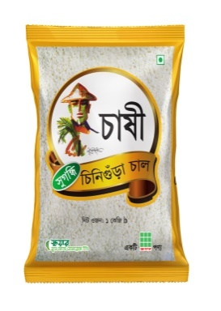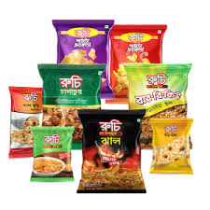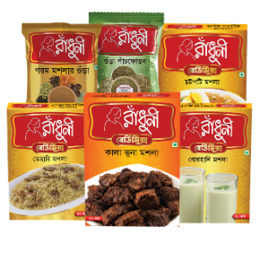

# **1.2**-The ultimate goals of our company:

* Continue the production and marketing of hygienic and quality food at minimum price.
* Finding out the needs of consumers’ and provide them with the products the aspire after.
* Explore new segments of internal market and place products in the international market.
* Maintaining the good will of the company by serving intrinsic quality of hygienic food products with authentic taste.
* Carrying on efforts to expand market globally and set up distribution network so as to make products available at doorsteps of customers.

# Chapter-2

**Executive Summary**

SQUARE Food & Beverage Limited is one of the leading food companies in Bangladesh. Since its inception in 2000, it has earned the trust of millions of consumers and created a strong foothold in the market with its high-quality products and customer experience. The company is USFDA certified along with ISO 9001:2000, ISO 22000.

SQUARE Food & Beverage Ltd. comprises five brands: Radhuni, Ruchi, Chashi, Chopstick, and Aaram. Radhuni, a cooking-essentials brand specializing in providing the best support for all endeavors in the kitchen, is the company’s flagship brand. Ruchi is a youth-centric brand that offers instant snacks. Chashi Aromatic Rice directly brings grains from the producer to the consumer’s doorstep and Chopstick is Bangladesh’s first tasting-salt-free Instant Noodles that promotes healthy snacking for children and health-conscious people. Aaram offers a range of 100% fruit juice with a focus on natural taste and trustworthy quality.

In addition to serving the local needs, SQUARE also exports to more than 30 countries to meet the increasing demand for quality products that meet international standards. Dedication to quality, consistent innovation in products, and customer services is quintessentially the driving force behind the company’s successes.

# 2.1-Products and Services

SQUARE Food & Beverage Limited offers a wide range of consumer products,

[**SPICES**](https://www.sfbl.com.bd/our_brands.php?brand_id=1)

Turmeric

Coriander

Spices

Chili

powder

Pachforan

# 2.2 [products](https://www.sfbl.com.bd/radhuni.php" \l ":~:text=Radhuni%20is%20the%20flagship%20brand,and%20for%20some%20Dairy%20Products.)

# Chapter-3

# 3.1-Business Plan

Food and Beverage Industry in Bangladesh Food and beverage manufacturing is a fast-growing business in Bangladesh that employs a significant portion of the population. Bangladesh's food and beverage business grew at an average annual rate of 7.7 percent between 2014 and 2017 (Akter, 2018). About 246 medium-sized food processing enterprises exist in Bangladesh, and about 8% of the entire industrial workforce is dedicated to promoting these businesses. Bangladesh's food industry has risen significantly in recent years. Many nations throughout the world benefit from the food exports of companies like PRAN and ACI. In terms of quality, flavor, and process, Bangladeshi food companies are on par with their international counterparts. Bangladesh's food industry is booming because to the efforts of these companies (Business Haunt). business strategy revolves around expanding its market share by reaching underserved rural communities, introducing eco-friendly product lines, and enhancing its distribution network. The company plans to:



Product

Marketing

Manageme

Analysis

Planning

Develop

Investme

Finance

1. Increase its product range with sustainable and locally sourced materials.
2. Strengthen e-commerce and digital marketing efforts.
3. Expand retail presence in urban and rural areas.
4. Build partnerships with local suppliers and producers.

# Chapter -4

**Sales and Cost Statistics**

|  |  |  |
| --- | --- | --- |
| **Product name** | **Cost** | **Sales** |
| Turmeric | $150,000 | $170,000 |
| Chili Power | $120,000 | $140,000 |
| Pachforan | $50,000 | $80,000 |
| Chanachur | $180,000 | $230,000 |
| Dal Bhaja | $80,000 | $100,000 |
| Mango juice | $110,000 | $150,000 |

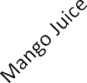

$250,000

$200,000

$150,000

$100,000

Cost

Sales

$50,000

$0

Squire food and Beverage Limited aims to optimize its cost structure by implementing more efficient production techniques and reducing waste in its supply chain.

**Referances-**

* **-**[**Radhuni**](https://www.kintaini.com/index.php?route=product/manufacturer/info&manufacturer_id=11)

[**Ruchi**](https://www.ruchifoodline.com/products)

[**Chashi**](https://www.sfbl.com.bd/our_product.php?brand_id=3&pid=59)